**Python Code Execution Diagram**

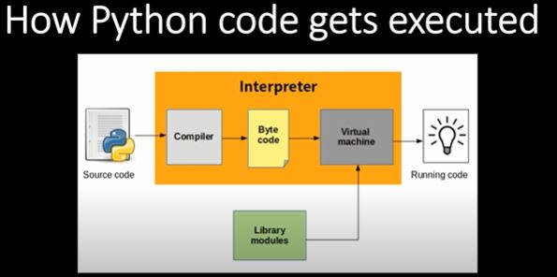

* Python Execution: Source code 🡪Interpreter(Compiler🡪Byte Code🡪Virtual Machine—Library Modules) 🡪Running Code

**Python:**

* Python is a popular programming language.
* Python can be used on a server to create web applications.

**Print function:**

* The print() function prints the specified message to the screen, or other standard output device.
* The message can be a string, or any other object, the object will be converted into a string before written to the screen.

**Indentation: #Spaces / Space error**

* Indentation refers to the spaces at the beginning of a code line / Python uses indentation to indicate a block of code.

**String:**

* A string is a data type used in programming, such as an integer and floating point unit, but is used to represent text rather than numbers
* Ex: print(hello) // Print is function // hello is string // Array size is 5 // Indices Starts with 0 So if array size is 5 then it will be 0 1 2 3 4 (total 5) So h store in 0 , e store in 1 so on…

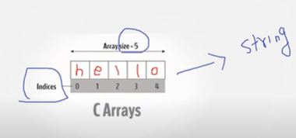

**Single & Double Quote String**

* String variables can be declared either by using single or double quotes:
* but for this case we won’t use single quote Ex: Hobbies = ‘I don’t like jackfruit’ (don’t)So in this case we need to use double quote

**multiline string**

* you can add a multiline string (triple quotes) in your code, and place your comment inside it

**Variables**

* Variables are containers for storing data values
* A variable is created the moment you first assign a value to it.
* Rules for Python variables:
  + start with a letter or the underscore character
  + A variable name cannot start with a number
  + A variable name can only contain alpha-numeric characters and underscores (A-z, 0-9, and _ ) /

**Case Sensitive**

* Variable names are case-sensitive
* Ex: Age = 30 ; age = 40; AGE = 40 (So total 3 variables)

**Casting**

* Type Casting is a process in which we convert a literal of one type to another
* Inbuilt functions int(), float() and str() shall be used for typecasting
* Ex: a=100 print(type(a) / OP:int / a=100 ; b=str(a) print(type(b)) OP:srt

Numbers: Integer, Float & Complex

Colon (:) :

Functions:

Keyword:

Operations:

Content:

Primitives: Numbers, Strings, Booleans

Collections: Lists, Dictionaries, Sets

Control Statements: if & elif, loops, etc

Range, in, output, input, tuples

Classes:

* Classes provide a means of bundling data and functionality together.